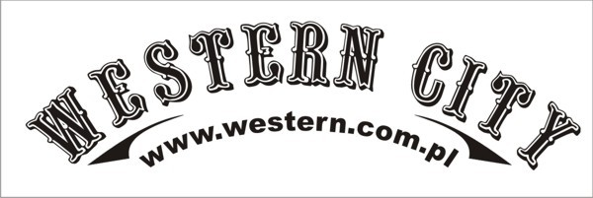

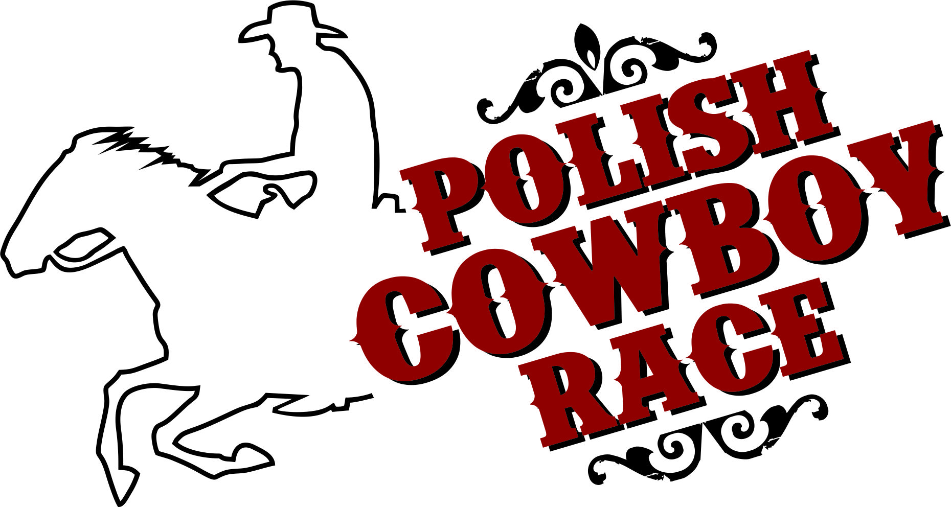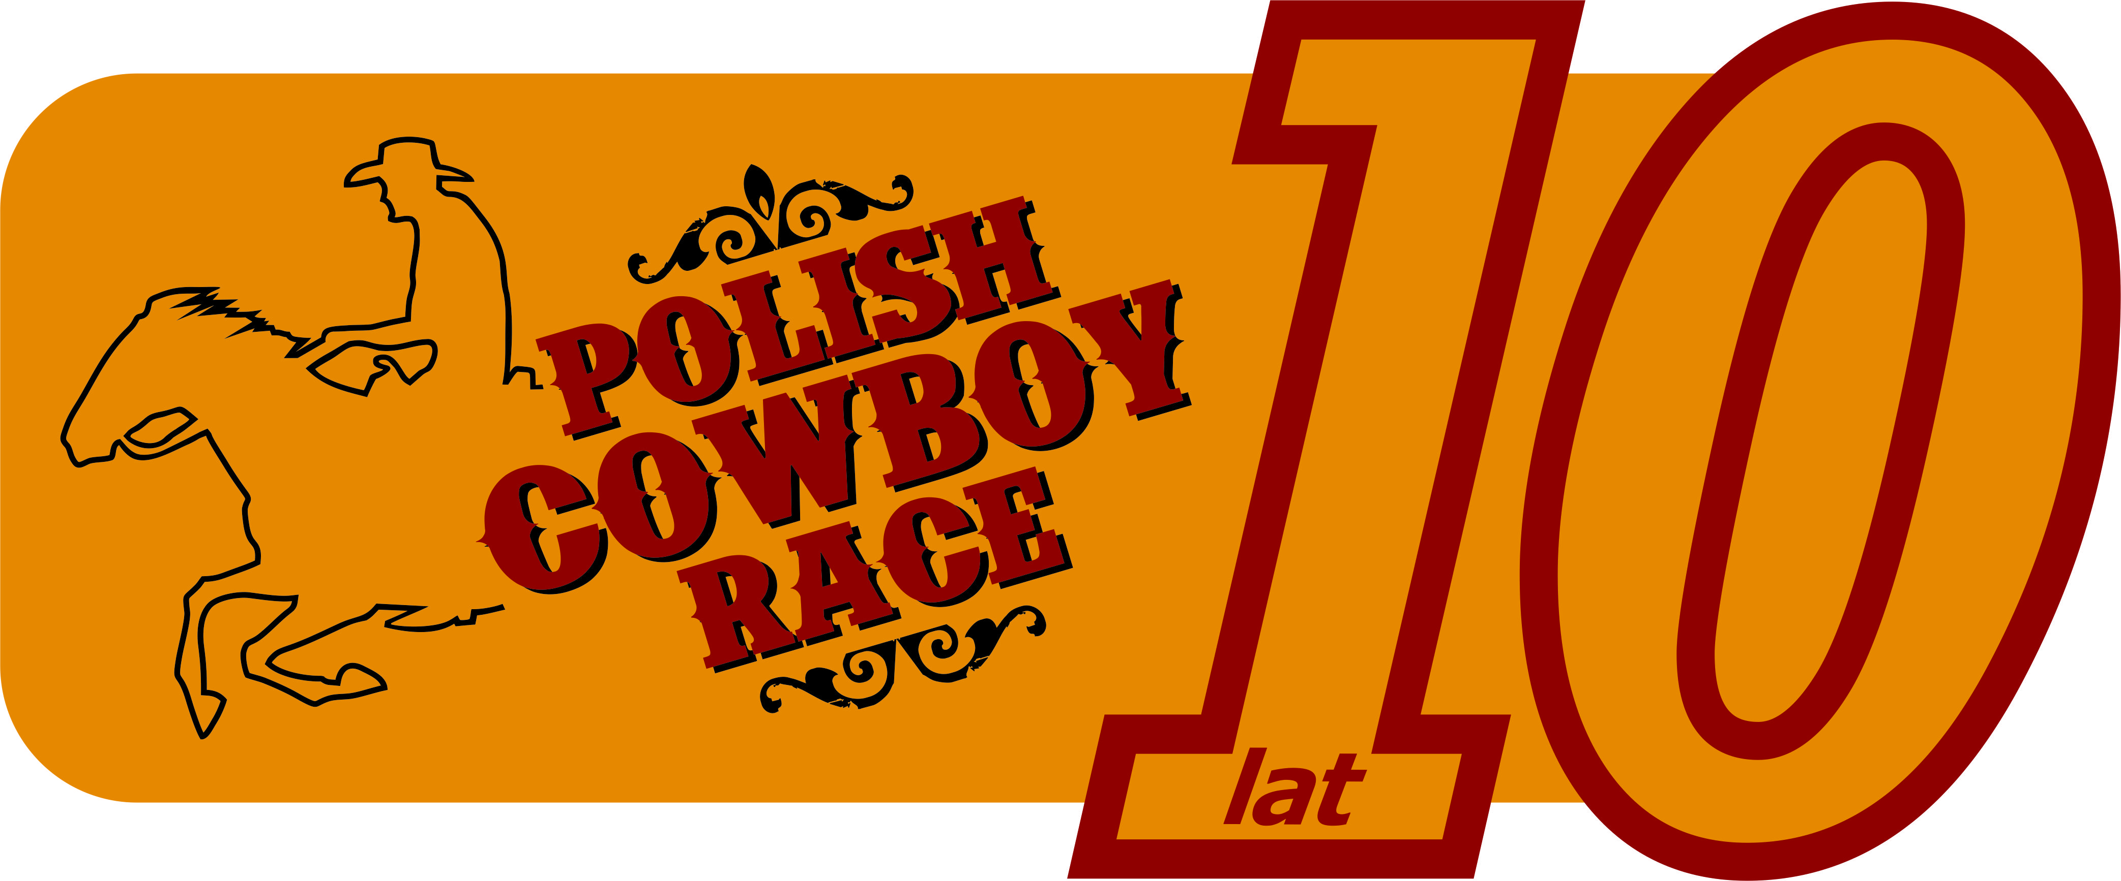

POLISH COWBOY RACE FOUNDATION
and
WESTERN CITY
invite you to
X POLISH INTERNATIONAL
CHAMPIONSHIPS IN
POLISH COWBOY RACE
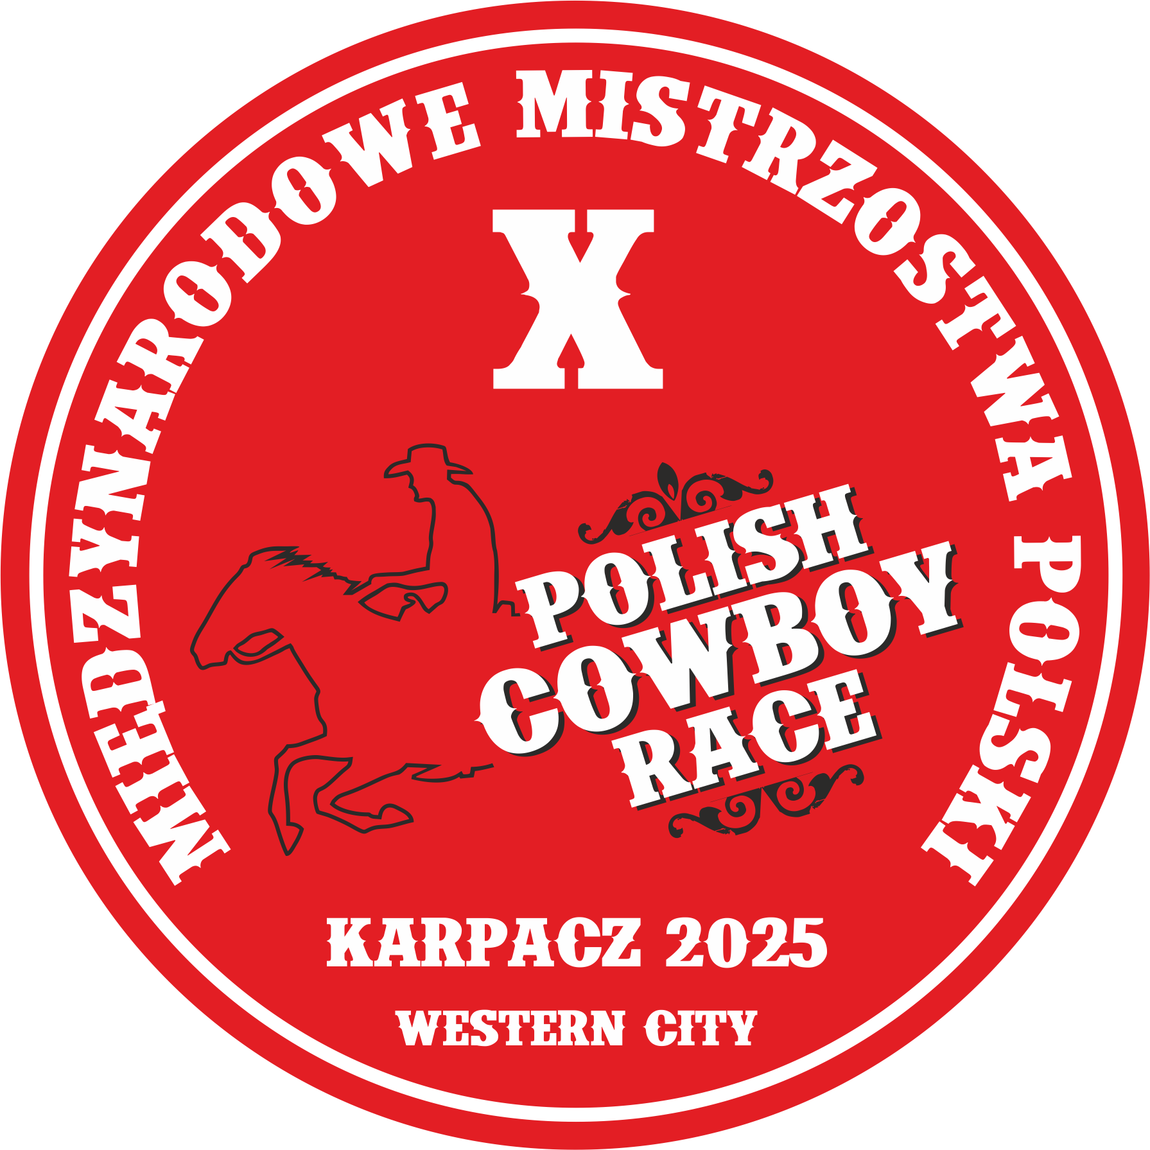

Competitions rules for X Polish International Championships in Polish Cowboy Race
(prepared in accordance with the Regulations for organizing, conducting, and participating in competitions for the Polish Cowboy Race discipline in 2025)
Termin: 19-21 September 2025 – the first competitions each day will begin at 12.00, 10.00 and 10.00 respectively.
Note! The competition start time may change (after the registration deadline).
Location: Western City, Ściegny, near Karpacz.
Participants: the competition is open to all riders practicing western riding style.
Competition office hours:
18th September – 18.00 – 20.00
19th September – 9.00 – 14.30; 15.30 – 17.00
20th September – 8.30 – 14.30; 15.30 – 17.00
21th September – 8.30 – 14.00
Head of competition office: Beata Zdrzalik–Grobelna (speaks German and English).
Applications will be accepted until: September 6, 2025 via email: biuro.grobelna@gmail.com
Applications must be submitted using the official registration form, which can be found on the website.
Classes as part of the X International Polish Championships in Polish Cowboy Race (PCR):
- Youth
- Cowboy Trail
- Cowboy Race
- Team Cowboy Race
- Amateur
- Cowboy Trail
- Cowboy Race
- Team Cowboy Race (class in class with Open)
- Cowboy Parallel Race (class in class with Open)
- Open
- Cowboy Race
- Team Cowboy Race (class in class with Amateur)
- Cowboy Parallel Race (class in class with Amateur)
Divisions:
- Youth – this division is for riders who, before the start of the season (the season begins with the first PCR event of the year), are at least 11 years old and have not yet turned 15. A rider who turns 11 before the X International Polish Championships is also eligible to compete. If a rider turns 15 during the season, they remain in the Youth class until the end of that season. Horses must be at least 4 years old.
- Amateur – a division for riders who are 15 years old or older (no longer meeting the criteria for the Youth division). This division is designed to, amongst the others, allow riders to compete in PCR by offering patterns with a lower level of difficulty. Horses must be over 4 years old.
Riders cannot compete in this division if they:
  - placed on the podium at least three times in Cowboy Race Amateur classes during two previous seasons,
  - won first place in the Riders of The Year ranking in the Amateur division in previous season,
  - hold qualifications or certifications such as: instructor and/or trainer of recreational/sports horse riding, equestrian tourism leader, or have official sports classifications in equestrian disciplines and this is their next season competing in the Polish Cowboy Race
  - derive financial benefits from any systematic activity related to horseback riding or training of horses and riders in either classical or western riding styles.
In their first season competing in the Polish Cowboy Race in the Amateur division, riders who hold certifications or qualifications—such as recreational or sport riding instructors and trainers, certified horse tourism guides, or riders with official sport classifications in equestrian sports—are allowed to participate, provided they do not receive financial benefits from any regular activity related to horseback riding or the training of horses and riders in either classical or western style. In the following season, these riders are required to compete in the Open class.
IMPORTANT! Riders in the Amateur division are required to submit an appropriate declaration (annex no. 1 or no. 2) confirming that they meet the conditions for competing in this division - either by email to the Polish Cowboy Race Foundation or directly to the competition organizer. A rider who has not submitted the required declaration is not allowed to compete in Amateur class events.
- Open – The minimum age for riders in this division is 15 years. Riders must compete in this division if they meet any of the conditions listed in section II/2, points a to d. Horses must be over 4 years old.
- Riders that have been qualified to Open division in the previous years cannot start in the Amateur division. Note! A rider from the Amateur division, who has advanced to the Open division due to their results, may compete in the Amateur division on a horse that has never participated in PCR competitions. This rule applies only to the first season of the pair's participation. In the following season, they must compete in the Open division.
- In the Cowboy Trail Youth, Cowboy Trail Amateur, Cowboy Race Youth, and Cowboy Race Amateur classes, non-competitive entries (NC) are allowed. It is recommended that this option be used by those who want to try their hand at the Polish Cowboy Race, as well as by riders from the Open class riding horses competing for the first time, for whom the Open-level patterns may be too difficult. A non-competitive start counts toward the horse’s start limit at the event. All formal requirements must be fulfilled, and participants must comply with all regulations governing participation in competitions organized by the PCR Foundation. Minimum age requirement – 11 years old, reached at least one day before the competition. Riders competing non-competitively are not ranked, do not participate in the prize distribution, and are not required to attend the awards ceremony.
IMPORTANT! The organizer reserves the right to cancel the option of non-competitive entries (NC) in the event of a high number of participants
* In case of any issues with registering for the appropriate class, please contact Jacek Grobelny.
Event manager for X Polish International Championships: Jacek Grobelny.
Main judge: Dawid Brzeziński.
Veterinarian: Natalia Kriesel (+48 662 177 368).
Fees:
Youth class - only entry fees apply. For each horse-rider pair, the fees are as follows: one class – 100 PLN (25 €), two classes – 180 PLN (45 €), three classes – 240 PLN (60 €).
Amateur and Open classes:
Registration fee: 120 PLN (30 €) per horse-rider pair
Entry fees - one class – 100 PLN (25 €), two classes – 180 PLN (45 €), three classes – 240 PLN (60 €), four classes – 280 PLN (70 €)
Non-competitive entry (NC) in CTY, CTA, CRY, and CRA classes: 100 PLN (25 €), no registration fee required.
IMPORTANT! All competitors are required to use Polish Cowboy Race Foundation numbers, which will be available for purchase at the competition office. The cost is 30 PLN (8 €) per horse-rider pair. These numbers are valid for all official PCR competitions.
The regulations of the Polish Cowboy Race Foundation apply and are available at the following link:
https://www.cowboyrace.com/competition/rules-and-event-organization/
IMPORTANT! All participants directly involved in the X Polish International Championships must be familiar with the PCR regulations.
Any discussions with judges regarding the rules and their interpretation are strictly prohibited and may result in the disqualification of the horse-rider pair from the competition.
Participants have the right to file protests according to the Protest Submission and Review Procedure for Polish Cowboy Race competitions in 2025, which is available at the link provided above.
NOTE! In cases not covered by these regulations, the provisions of other regulations and rules of the Polish Cowboy Race Foundation shall apply.
Each rider participating in the X Polish International Championships must have the following documents:
- document confirming identity and age,
- sports medical booklet or a valid medical certificate confirming the ability to participate in equestrian competitions or a statement by the rider declaring they are in good health and fit to compete (in the case of minors, this statement must be signed by their legal guardians),
- consent from legal guardians for minors to participate in the competition (valid for this event),
- consent for the use of the rider’s image for marketing purposes – for the promotion of the event or the Polish Cowboy Race foundation (in the case of minors, this consent must be signed by legal guardians),
- consent for the processing of the rider’s personal data (provided during registration) by the event organizer and persons authorized by them, for the purpose of organizing and conducting the X Polish International Championships in Polish Cowboy Race (for minors, this consent must be signed by legal guardians),
- statement by the rider regarding their classification as Amateur in the first and subsequent years of participation,
- horse’s passport (or another document confirming the horse’s identity, age, and health status, including valid vaccinations),
- foreign riders must present a veterinary certificate confirming the horse’s health condition.
Prizes: Cups, medals, and material prizes.
Horse Documentation: passport + valid vaccinations not older than six months (for horses of foreign competitors – veterinary certificate confirming the horse’s health condition).
Technical Conditions:
Indoor arena with stands – 28 x 56 m, sand footing.
Outdoor arena with stands – 35 x 60 m, sand footing.
NOTE! Competitions will be held either in the outdoor arena or in the indoor arena, depending on weather conditions.
Horse stalls: permanent, 3 x 3 meters, straw bedding.
Note! The number of stalls is limited.
Stall Prices:
Price per stall for 1 day – 70 PLN (17.5 €)
Price per stall for 2 days – from Thursday to Friday, Friday to Saturday, or Saturday to Sunday: 120 PLN (30 €)
Price per stall for 3 days – from Thursday to Saturday or Friday to Sunday: 180 PLN (45 €)
Price per stall for 4 days – from Thursday to Sunday: 240 PLN (60 €)
For each additional day beyond 4 days: 70 PLN (17.5 €)
Price includes hay, water, and initial bedding (straw).
Horse feeding: concentrate feed must be provided by the rider; hay is included in the stall price.
Competition Schedule (the timetable is subject to change):
19th September
8.00 – 10.00
Veterinary inspection
12.00
Cowboy Trail Youth (pattern walk-through at 11:30)
Cowboy Trail Amateur
Cowboy Race Youth – Joanna Kubisa Memorial
Awards Ceremony
Additional attractions
September 20
10.00
Cowboy Race Amateur (pattern walk-through at 9:30)
Team Cowboy Race Youth
15:00
Opening ceremony of the X Polish International Championships in PCR + awards ceremony for morning competitions
16:00
Additional attractions
21st September
10.00
Team Cowboy Race (course walk at 9:30)
Cowboy Parallel Race
Cowboy Race Open – Competition for an award of Bohdan Smoleń Spurs
Awards ceremony for all competitions
Closing of the X Polish International Championships in PCR
IMPORTANT! RIDERS ARE REQUIRED TO PARTICIPATE ON HORSEBACK IN THE OPENING CEREMONY OF THE X POLISH INTERNATIONAL CHAMPIONSHIPS IN POLISH COWBOY RACE.
Please read – important!
- In case of a low number of entries, the organizers may shorten the competition to two days.
- For safety reasons, a specific system for moving on horseback and with horses will be in place during the competition; failure to comply with the organizers’ guidelines may result in the disqualification of the rider from the competition.
- All riders, grooms and other persons on horseback during the competition are kindly asked to observe safety rules and exercise extreme caution; special attention should be paid to pedestrians as well as other riders and their horses.
- Leaving horses unattended (e.g., tied to fences) on the competition grounds (Western City, arena, and surroundings) is prohibited.
- Consumption of alcohol by competitors during the competition is forbidden – both before the competitions they participate in and before the ceremonies: opening and awards.
- After the awards ceremony, it is possible to take photos with the riders and their horses (preferably with materials from the organizer and sponsors).
- In the Team Cowboy Race (TCR), a horse may compete twice, provided it is ridden by riders from the Open and Amateur classes participating in different teams; this horse does not participate in the draw related to the situation described in point VII/2/7 of the 2025 PCR rules. Each pair must pay the registration and entry fees.
- In Cowboy Trail Youth (CTY), Cowboy Trail Amateur (CTA), Cowboy Race Youth (CRY) and Cowboy Race Amateur (CRA), a horse may compete twice but with different riders.
- All competitors approved by the organizer to participate in the Polish Cowboy Race must comply with all provisions arising from the regulations, rules and resolutions of the Polish Cowboy Race Foundation.
- The organizer requires riders to participate on horseback in the official opening ceremony of the event; all other participants attend the opening on foot.
- The organizer may announce the final awards procedure during the competition.
- All riders participating in a competition are required to take part in the awards ceremony.
- A horse may participate in up to 5 runs per day during the competition.
- Riders are required to wear western attire – festive, neat, and uniform.
- Riders must wear the full outfit described in these regulations at all times while on the arena during the competition (e.g., during warm-up, pattern walk-through, competition and awards ceremony).
- The organizer reserves the right to make changes to the competition program.
- The organizer is not responsible for accidents or thefts during the competition and transportation.
- The organizer emphasizes that any case of inhumane treatment of a horse will result in the disqualification of the rider.
- Copies of score sheets will be posted immediately after each competition on the notice board near the main stands in the indoor arena.
- The rider has the right to file a protest with the competition manager according to the protest procedures applicable at Polish Cowboy Race Foundation events. The procedure is available for review at the competition office.

REGISTERING FOR THE COMPETITION CONSTITUTES FULL ACCEPTANCE OF THIS REGULATION AND ALL POLISH COWBOY RACE RULES.
You are warmly invited!

